Section 4 I
Instructions to Artists:

Artist should complete the entry form including sections 1, 2, 3
- and 4.
Have completed BEFORE you get to the college on entry day.

Sections 1 and 2
Please complete as indicated. Please print legibly.
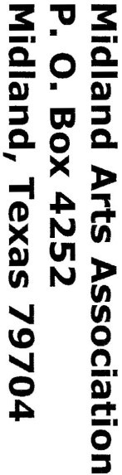
Please do not cut Section 1 and Section 2 apart. That will be done by MAA after judging takes place.

Section 3 - Tags
The tags should be completed and taped to the back of the piece (or bottom for ceramics, sculpture, etc.) . Please be sure that the tag (A, B, C) is on the correct piece and matches your entry form.

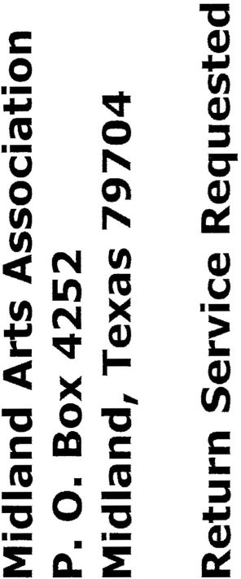
Section 4 - Your address Please legibly address the card to yourself . An envelope will be
provided for mailing your “accepted/non-accepted”
Entries.
Midland Arts Association and Midland College present the 41th Annual Fall Juried
Art Exhibition

McCormick Gallery Allison Fine Arts Building Midland College

Oct. 10 - Nov. 15, 2019

-· - -----------------------
Title: -----------
Title: ------------
-----------------------------------------
_A: Artist: Phone:

Calendar
Saturday,Oct. 5
Monday, Oct. 7
Thursday,Oct. 10
Thursday, Oct. 10
Friday, Nov.15 Saturday, Nov.16

Midland Arts Association and Midland College present the
... ---------------------- --- ---------------
_C: Artist: Phone:
Price ------------

42th Annual Fall Juried Art Exhibition October 10 – November 15, 2019
Tags for backs of Works
_
_
_
_
_
-----------------------------------------

Check out our website at:
www.midlandartsassociation.org or, www.maatx.org

McCormick Gallery, Allison Fine Arts Building Midland College, 3600 N. Garfield, Midland, Texas 79705

Entries received at Midland College 10 a .m.-2 p.m
Acceptance/Non -acceptance Cards Emailed
Pick up non-accepted work, Allison Fine Arts Hallway 4 p.m.-6 p.m. Opening Reception and awards ceremony 6:00p.m.-8:00p.m. Fall Show Closes 5p.m.
Pick up exhibited work 11a.m.-1p.m.
Title:
Category:
Price:
Category:
Price:

Category:
_B: Artist: Phone:
Juror: Shannon Cannings is from Pittsburgh, Pennsylvania. She received her BFA and MFA in painting
at the Tyler School of Art in Philadelphia, and Syracuse University in New York respectively.
She has been teaching at Texas Tech University for 19 yrs. Her work is represented by galleries
in Houston, Dallas, and Lubbock. As a four-time Hunting Prize finalist, her work has been
included in New American Paintings, the Texas Biennial, and across 12 states in solo and
group exhibitions.
Section 3

Entry Fees:
Midland Arts Association/Midland College 42th Annual Fall Show
Oct. 10- Nov. 15, 2019
McCormick Gallery, Allison Fine Arts Building, Midland College
$45 total for non-MAA member_________Total_________

MAA members-$35 total for up to 3 entries, Student Entry Fee: $20 with student ID.
Non-members $45 total for up to 3 entries. *New* Individual Membership fee: $60 good through
12/31/19. *This covers all people joining MAA on Saturday, October 5th, 10am-2pm.*
Category / Price

Entries *Limited to three per artist. Categories: Portrait, Landscape, Still Life, Abstract, Animal, & 3D. All media accepted.
A
.A
.A
_
Midland Arts Association retains the right to screen entries.
We cannot guarantee the safety of artwork NOT picked up on time. For late pick up, contact Michael Hubbard, 432-685-4651 OR mhubbard@midland,edu
Entry Form {Please Print)
_
_
_
Entry Date Artwork must be brought to the Allison Fine Arts Building between 10a.m. and 2

p.m. Saturday, Oct.5th. Works sent by commercial carrier must arrive no later than Friday, Oct.4th. Crating must be re-useable for return. Shipping must be prepaid & shipped to MAA, c/o Midland College, AFA 185, 3600 N. Garfield, Midland, Texas, 79705.

Conditions MAA takes 20 percent commission on all sales from the exhibit. All selected entries must remain for the duration of the show. No Exceptions.
Non Liability Midland Arts Association and/or Midland College, including employees and agents, shall not be liable for loss or damage to any works of art entered. Participation indicates that the entrant understands and accepts this clause and conditions as stated.
c.
Entry Fee:
$35 total for MAA mmembers
Section 1
Name
Email

Entries:
A.

B.

This program is partially supported by the Arts Council of Midland
Phone

For further information contact Leslie Slaughter, 432-559-6820, email - leslie.slaughter@gmail.com or go to our website: www.maatx.org or www.midlandartsassociation.org
Section 2
Artist: _ Titles: A:
B:
C:

