Section 4 I
Instructions to Artists:

Artist should complete the entry form including sections 1, 2, 3
- and 4.
Have completed BEFORE you get to the college on entry day.

Sections 1 and 2
Please complete as indicated. Please print legibly.
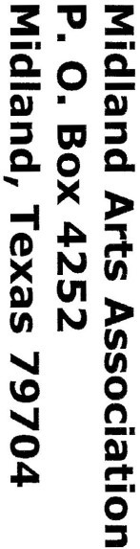
Please do not cut Section 1 and Section 2 apart. That will be done by MAA after judging takes place.

Section 3 - Tags
The tags should be completed and taped to the back of the piece (or bottom for ceramics, sculpture, etc.) . Please be sure that the tag (A, B, C) is on the correct piece and matches your entry form.

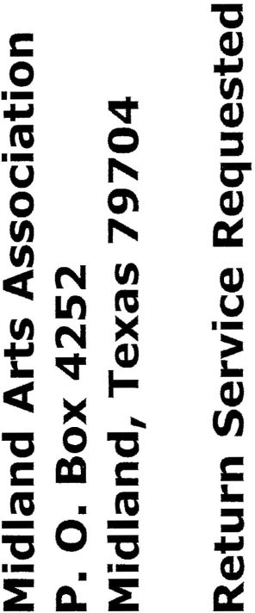
Section 4 - Your address Please legibly address the card to yourself . An envelope will be
provided for mailing your “accepted/non-accepted”
Entries.
Midland Arts Association and Midland College present the 41th Annual Fall Juried
Art Exhibition

McCormick Gallery Allison Fine Arts Building Midland College

Oct. 11 - Nov. 9, 2018

-· - -----------------------

